青 岛 理 工 大 学
课程实验报告
课程名称 | Web开发技术基础 | 班级 |  | 实验日期 | 2017.10.27
姓名 |  | 学号 |  | 实验成绩
实验名称 | 实验2 CSS实验
实验目  及要求 | 掌握CSS基本选择器和复合选择器的语法，HTML中应用CSS的四种方式，以及CSS+DIV实现页面布局。
实验环境 | Sublime + Chrome
实验内容 | 1、理解课本P182页示例16-1的代码，并参照代码写出该例的页面布局  2、理解课本P185页示例16-2的代码，并参照代码写出该例的页面布局  3、实现课本P180图15-21的页面布局效果，要求：所有相邻边框间的距离为10px，所有子盒子宽度（width）为100px。  4、完成课本P188习题16的上机题。P190图16-3中图片、菜单内容、文字内容自选。
实  验  步  骤 | - 根据图片所示布局推测代码  - 查看课本验证猜想  - 从课本代码中获取宽高的具体数值  - 敲代码并及时修正错误
调  试  过  程  及  实  验  结  果 | 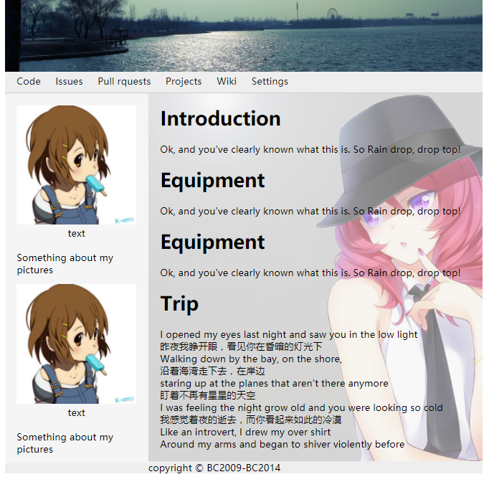  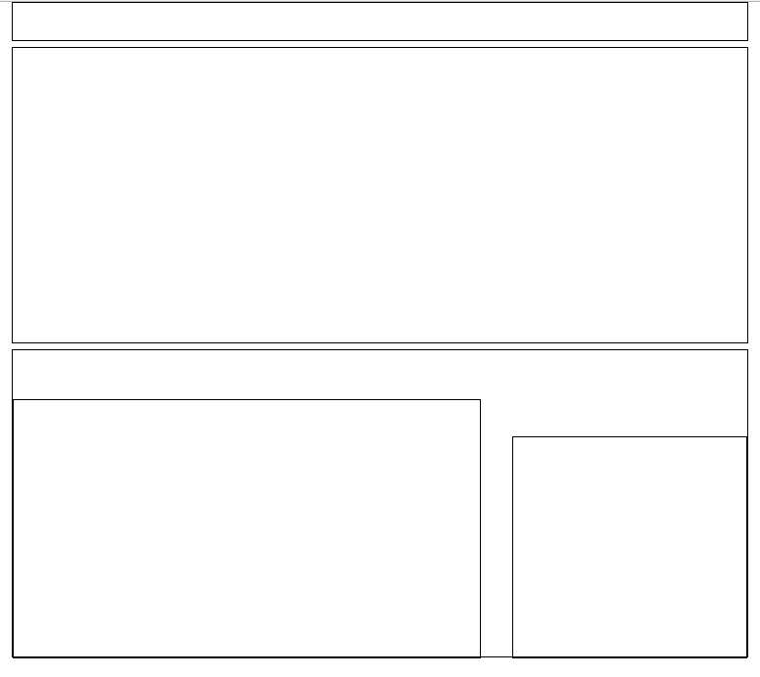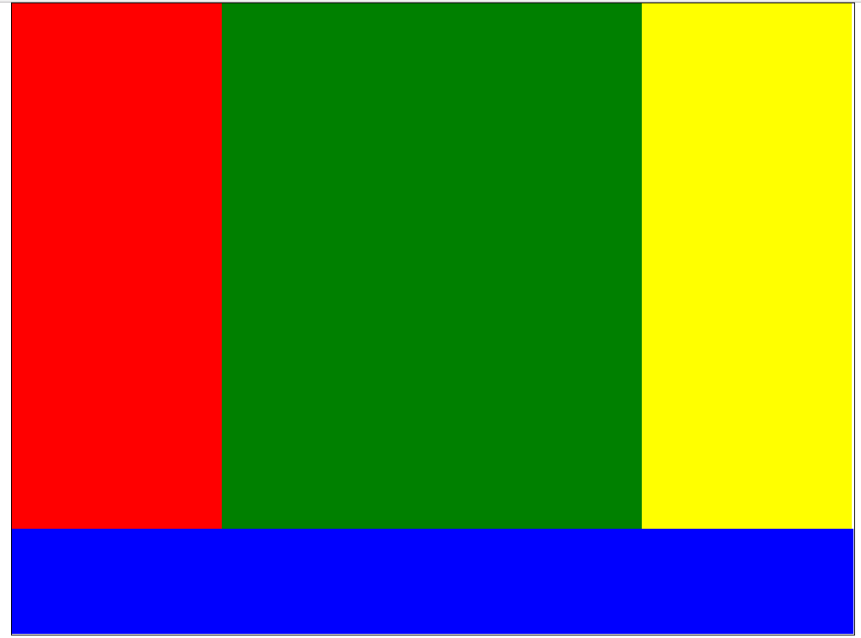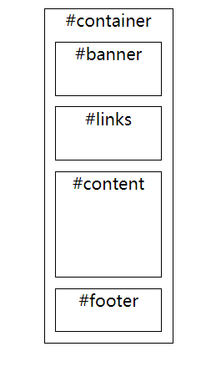
总  结 | - div相对自身的负值偏移只有margin-left,margin-top,top,left,right,bottom可以做得到，margin-right和margin-bottom是做不到的。  - box-sizing只对padding有效，对border无效。
源程序 | 1-16-1.html  <style>  *{  margin: 0;  padding: 0;  }  #apTop{  width: 600px;  margin: 0 auto;  border: 1px #000 solid;  height: 30px;  }  #apCenter{  width: 600px;  margin: 5px auto;  height: 240px;  border: 1px #000 solid;  }  #apMain{  width: 600px;  height: 250px;  margin: 5px auto;  border: 1px #000 solid;  }  #apLeft{  width: 380px;  height: 210px;  float: left;  border: 1px #000 solid;  position: relative;  bottom: -40px;  }  #apRight{  width: 190px;  height: 180px;  border: 1px #000 solid;  float: left;  position: relative;  right: -26px;  bottom: -70px;  }  </style>  <body>  <div id="apTop"></div>  <div id="apCenter"></div>  <div id="apMain">  <div id="apLeft"></div>  <div id="apRight"></div>  </div>  </body>  2-16-2.html  <style>  *{  margin: 0;  padding: 0;  }  #container{  width: 802px;  margin: 0 auto;  border:1px #000 solid;  height: 600px;  }  #left{  width: 200px;  height: 500px;  background: red;  float: left;  }  #middle{  width: 400px;  height: 500px;  background: green;  float: left;  }  #right{  width: 200px;  height: 500px;  background: yellow;  float: left;  }  #footer{  width: 100%;  height: 100px;  background: blue;  float: left;  }  </style>  <body>  <div id="container">  <div id="left"></div>  <div id="middle"></div>  <div id="right"></div>  <div id="footer"></div>  </div>  </body>  3-15-21.html  <style>  #container{  border: 1px #000 solid;  width: 122px;  margin:0px auto;  }  #banner{  border: 1px #000 solid;  width:100px;  height: 50px;  margin: 10px;  }  #links{  border: 1px #000 solid;  width: 100px;  height: 50px;  margin: 10px;  }  #content{  border:1px #000 solid;  width:100px;  height: 100px;  margin: 10px;  }  #footer{  border: 1px #000 solid;  width:100px;  height: 40px;  margin:10px;  }  </style>  <body>  <div id="container" align="center">  <div>#container</div>  <div id="banner">#banner</div>  <div id="links">#links</div>  <div id="content">#content</div>  <div id="footer">#footer</div>  </div>  </body>  4-16-3.html  <body>  <div id="container">  <div id="header">  <div id="banner"></div>  <div id="nav">  <a href="">Code</a>  <a href="">Issues</a>  <a href="">Pull rquests</a>  <a href="">Projects</a>  <a href="">Wiki</a>  <a href="">Settings</a>  </div>  </div>  <div id="stage">  <div id="side">  <div class="item">  <img src="images/pzw.jpg" alt=""><br>  <span>text</span>  <div>  <p>Something about my pictures</p>  </div>  </div>  <div class="item">  <img src="images/pzw.jpg" alt=""><br>  <span>text</span>  <div>  <p>Something about my pictures</p>  </div>  </div>  </div>  <div id="content">  <h1>Introduction</h1><br>  <p>Ok, and you've clearly known what this is. So Rain drop, drop top!</p><br>  <h1>Equipment</h1><br>  <p>Ok, and you've clearly known what this is. So Rain drop, drop top!</p><br>  <h1>Equipment</h1><br>  <p>Ok, and you've clearly known what this is. So Rain drop, drop top!</p><br>  <h1>Trip</h1><br>  <p>  I opened my eyes last night and saw you in the low light <br>  昨夜我睁开眼，看见你在昏暗的灯光下 <br>  Walking down by the bay, on the shore,<br>  沿着海湾走下去，在岸边<br>  staring up at the planes that aren't there anymore <br>  盯着不再有星星的天空<br>  I was feeling the night grow old and you were looking so cold <br>  我感觉着夜的逝去，而你看起来如此的冷漠<br>  Like an introvert, I drew my over shirt <br>  Around my arms and began to shiver violently before  </p>  </div>  </div>  <div id="footer">  <span>  copyright © BC2009-BC2014  </span>  </div>  </div>  </body>  style.css  * {  margin: 0;  padding: 0; }  a {  color: #222;  font-weight: normal;  text-decoration: none; }  #container {  width: 800px;  margin: 0 auto; }  #container #header #banner {  width: 100%;  height: 120px;  background-image: url("../images/banner.jpg");  background-size: 100%;  background-position: center; }  #container #header #nav {  height: 30px;  padding: 5px 0 0px 10px;  background: #eee;  border-bottom: 1px #ccc solid; }  #container #header #nav a {  margin: 0 10px 0 10px; }  #container #header #nav a:hover {  text-decoration: underline;  font-weight: bold; }  #container #stage {  width: 100%; }  #container #stage #side {  width: 30%;  background: #f5f5f5;  box-sizing: border-box;  padding: 10px;  float: left; }  #container #stage #side .item {  text-align: center;  padding: 10px 10px 5px 10px; }  #container #stage #side .item img {  width: 100%; }  #container #stage #side .item div {  margin-top: 20px; }  #container #stage #side .item div p {  text-align: left; }  #container #stage #content {  width: 70%;  box-sizing: border-box;  padding: 20px;  float: left;  background-image: url("../images/maki.png");  background-position: center;  background-size: auto 100%; }  #container #footer {  width: 100%;  background: #eee; }  #container #footer span {  text-align: center; }

